**Batch** : B2 **Roll No**.: 1914078  **Experiment In-lab 4**

**1. Installation of PostGIS using Application stack builder.**

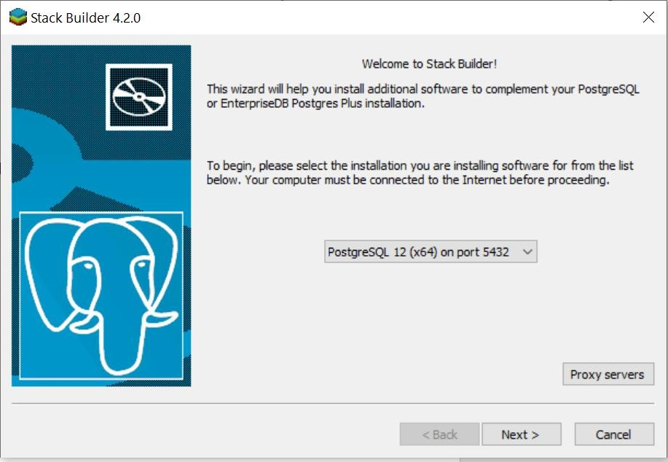

# Explore

A SDBMS(Spatial Database Management System) is a software module that

* can work with an underlying DBMS
* supports spatial data models, spatial abstract data types (ADTs) and a query language from which these ADTs are callable
* supports spatial indexing, efficient algorithms for processing spatial operations, and domain specific rules for query optimization
* A spatial database is a collection of spatial data types, operators, indices, processing strategies, etc. and can work with many postrelational DBMS as well as programming languages like Java, Visual Basic etc.

GIS(Geographic Information Systems) is a software used to visualize and analyze spatial data using spatial analysis functions such as

* Search Thematic search, search by region, (re-)classification
* Location analysis Buffer, corridor, overlay
* Terrain analysis Slope/aspect, catchment, drainage network
* Flow analysis Connectivity, shortest path
* Distribution Change detection, proximity, nearest neighbor
* Spatial analysis/Statistics Pattern, centrality, autocorrelation, indices of similarity, topology: hole description
* Measurements Distance, perimeter, shape, adjacency, direction
* GIS uses SDBMS to store, search, query, share large spatial data sets

HOW IS A SDBMS DIFFERENT FROM A GIS? SDBMS focuses on

* Efficient storage, querying, sharing of large spatial datasets
* Provides simpler set-based query operations
* Example operations: search by region, overlay, nearest neighbor, distance, adjacency, perimeter etc.
* Uses spatial indices and query optimization to speed up queries over large spatial datasets.

When creating tables, numeric parameters for integer numbers can be set as

* Int8 — [-128 : 127]
* Int16 — [-32768 : 32767]
* Int32 — [-2147483648 : 2147483647]
* Int64 — [-9223372036854775808 : 9223372036854775807]

Aliases:

* Int8 — TINYINT, BOOL, BOOLEAN, INT1.
* Int16 — SMALLINT, INT2.
* Int32 — INT, INT4, INTEGER.
* Int64 — BIGINT.

|  |  |
| --- | --- |
| FLOAT(*size*, *d*) | A floating point number. The total number of digits is specified in size. The number of digits after the decimal point is specified in the d parameter. |
| FLOAT(*p*) | A floating point number. If p is from 0 to 24, the data type becomes FLOAT(). If p is from 25 to 53, the data type becomes DOUBLE() |

-> AddGeometryColumn(varchar table_name, varchar column_name, integer srid, varchar type, integer dimension, boolean use_typmod=true);

Adds a geometry column to an existing table of attributes. The schema_name is the name of the table schema. The srid must be an integer value reference to an entry in the

SPATIAL_REF_SYS table. The type must be a string corresponding to the geometry type, eg, 'POLYGON' or 'MULTILINESTRING' . An error is thrown if the schemaname doesn't exist (or not visible in the current search_path) or the specified SRID, geometry type, or dimension is invalid.

# Executing Queries

**1. Creating Spatial Database**

CREATE DATABASE gisdb;

Enable PostGIS (includes raster)

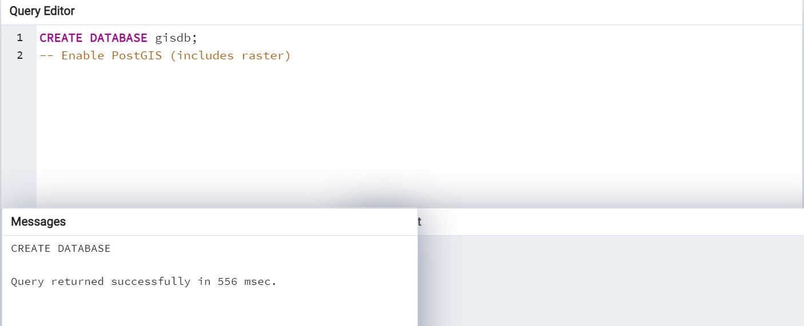

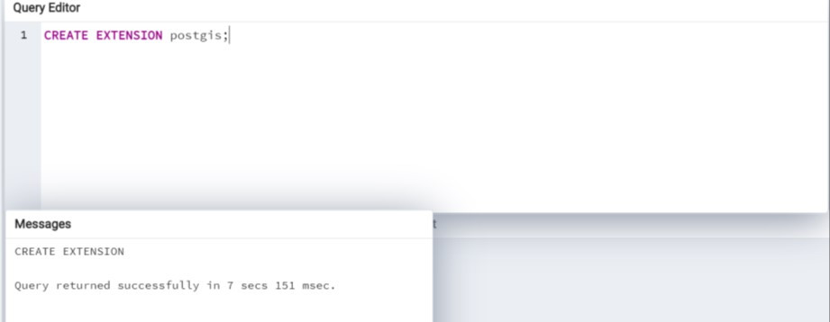

create table city (

gid int4 ,

AREA float8,

PERIMETER float8,

CITIES_ numeric(38,9),

CITIES_ID numeric(38,9),

CITY_NAME varchar,

GMI_ADMIN varchar,

ADMIN_NAME varchar,

FIPS_CNTRY varchar,

CNTRY_NAME varchar,

STATUS varchar,

POP_RANK int4,

POP_CLASS varchar,

PORT_ID int4

);

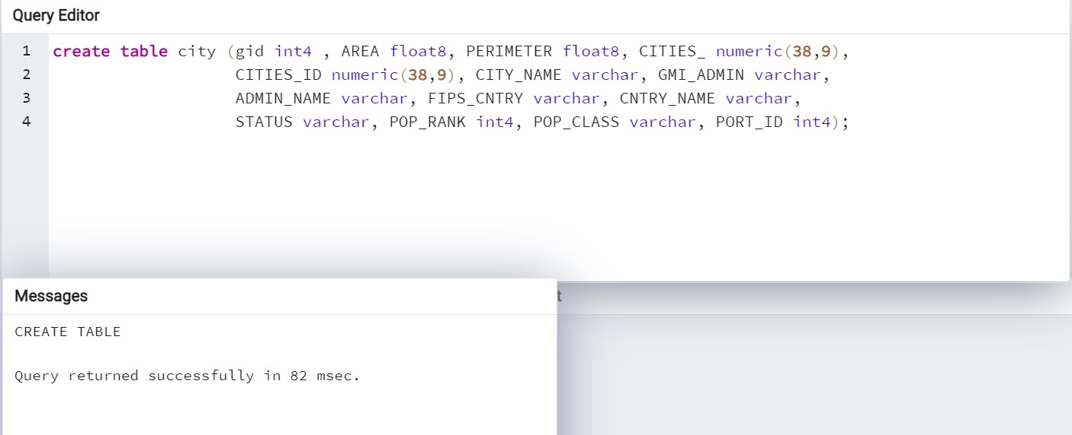

CREATE SCHEMA gis;

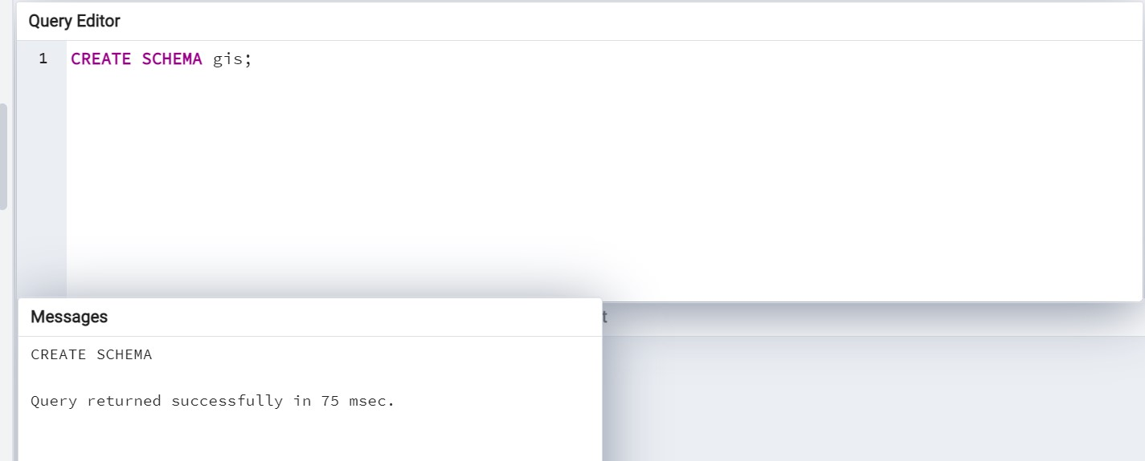

SELECT AddGeometryColumn('','cITy','the_geom','0','POINT',2);

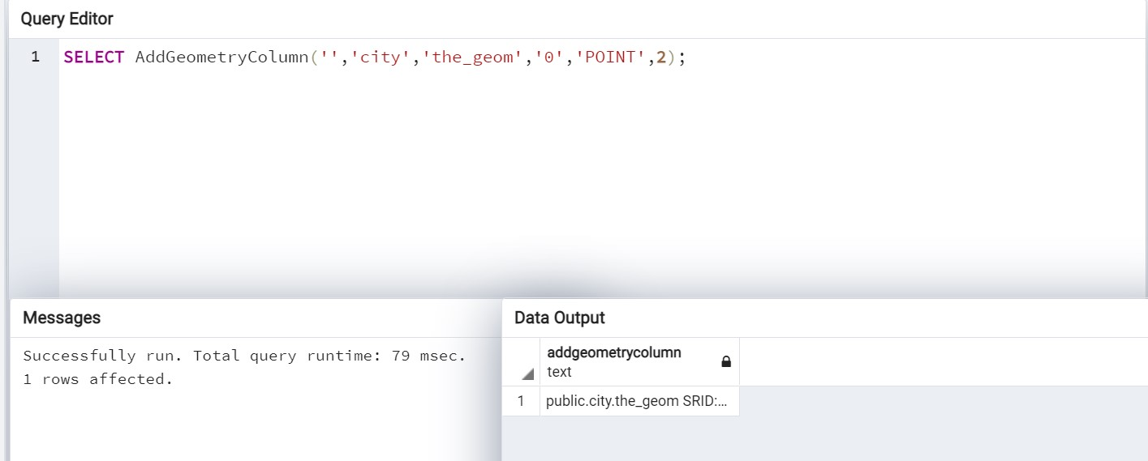

begin;

insert into city values

('0','0.000','0.000','20.000000000','53.000000000','Bismarck','USANDA','North Dakota','US','United States','Provincial capital','7','Less than 50,000','0',ST_GeomFromText('POINT (-100.7833025517 46.79999918311)',1) );

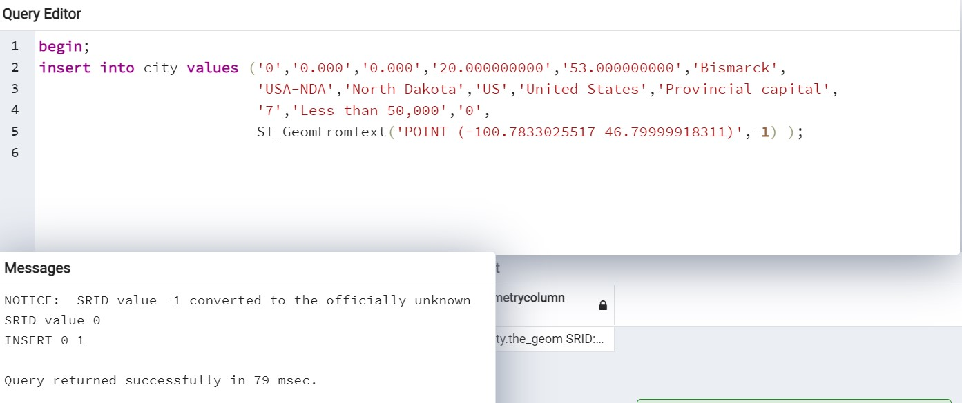

insert into city values ('15','0.000','0.000','803.000000000','2000.000000000',

'Jefferson City','USA-MOS','Missouri','US','United States',

'Provincial capital','7','Less than 50,000','0',

ST_GeomFromText('POINT (-92.1689985517 38.58000218311)',-1) );

end;

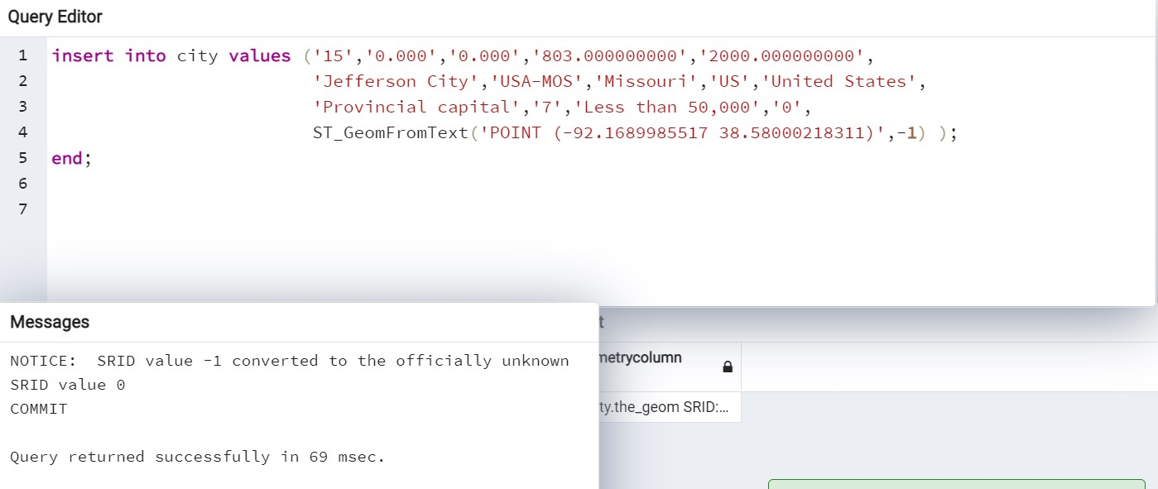

create table river (gid int4 , NAME varchar, DIAK_CDE varchar, NAME2 varchar, DIAK_CDE2 varchar, TYPE varchar, STATUS varchar, NAVIG varchar);

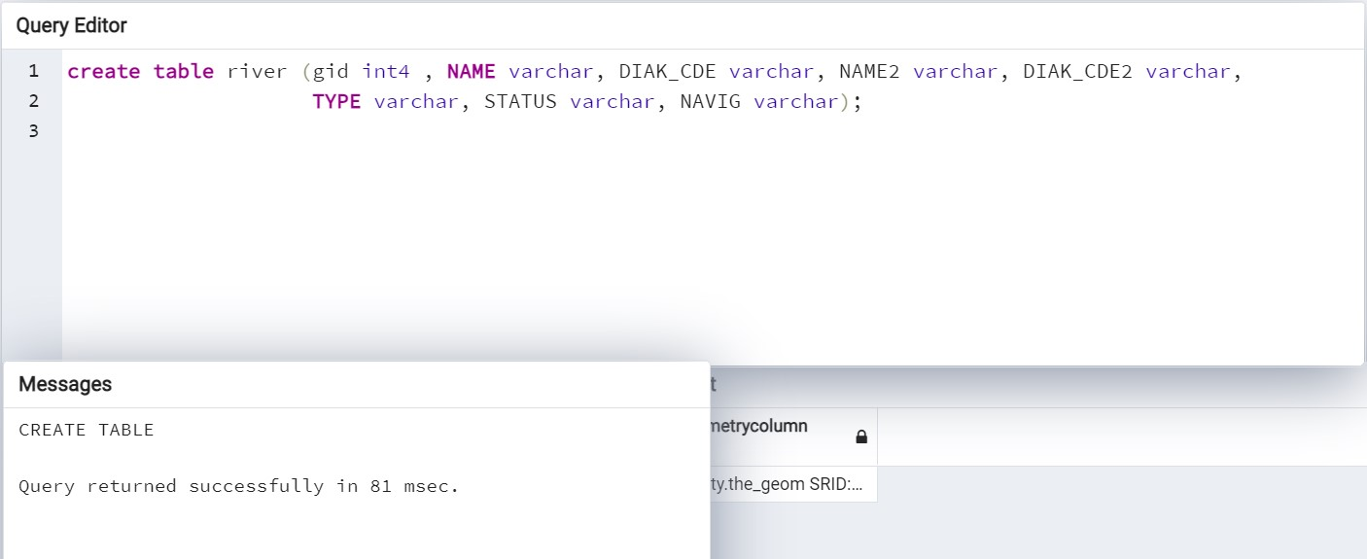

select AddGeometryColumn('','river','the_geom','-1','MULTILINESTRING',2);

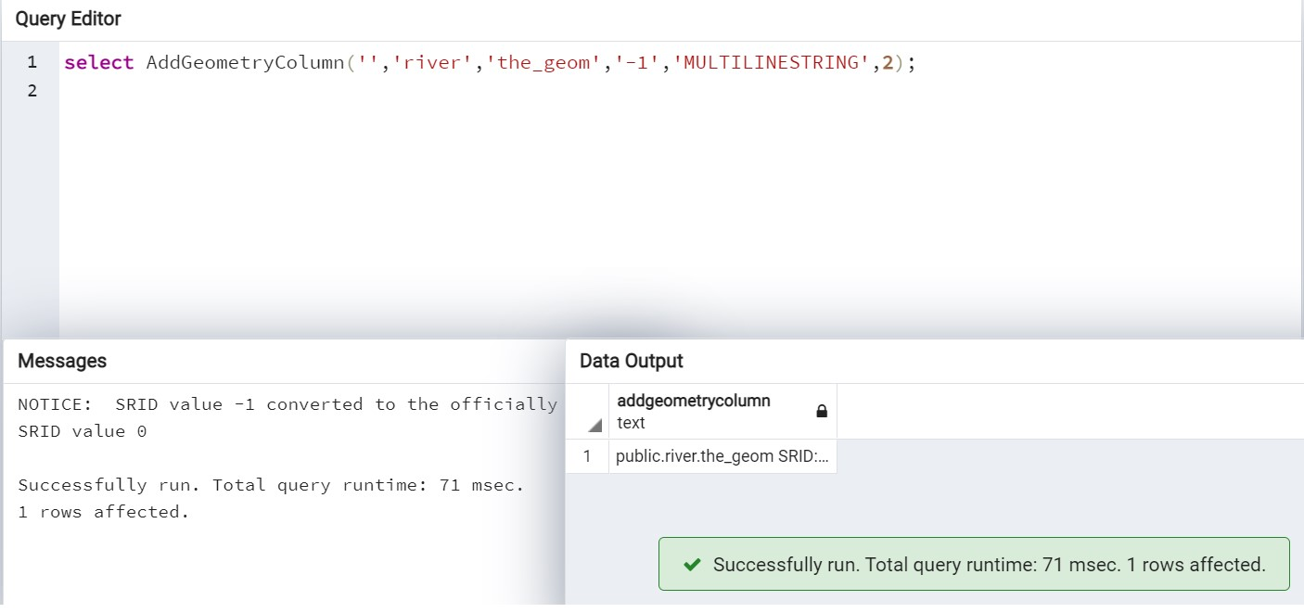begin;

insert into river

values('0','Manistee',NULL,NULL,NULL,'stream','secondary','nonnavigable',ST _GeomFromText('MULTILINESTRING ((-86.350807 44.252991 ,-86.179604 44.221001 ,-86.079018 44.244381 ,-85.914146 44.22971 ,-85.908544 44.229205 ))',-1) );

